Line-Up Cards

**Line-Up Cards**

Coaches can download and print the team line-up cards. You don’t need a template cardstock anymore. It can be printed on regular paper or regular cardstock paper.

* **Please note that the Line Cards will only be available for teams that are posted. Admins with access can go to Teams – Manage Teams to post rosters for each finalized team.** BOARD MEMBER NEEDS TO GO INTO TEAM CENTRAL and click TEAM DIRECTORY then click on Manage Teams. Make sure the correct program is in the search area and scroll down to OTHER Allow volunteers to edit jersey numbers – make sure that is clicked YES

**Here is how the coaches can access the Line-up cards:**

**From Volunteer's My Account Page**

Click on **Visit Team Page** for any roster that has been posted.

[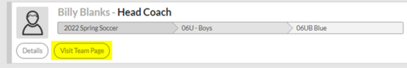](https://wiki.ayso.org/wiki/File:Image.png)  
On the team page, click on the Roster tab to then see the Print Team Line Up

[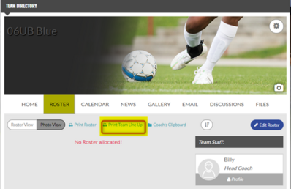](https://wiki.ayso.org/wiki/File:Team_Page_Print_Line_up.png)

**From the Team Directory**

Select Team Roster

[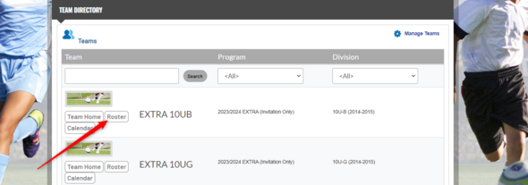](https://wiki.ayso.org/wiki/File:Team_roster.png)

Select Roster

[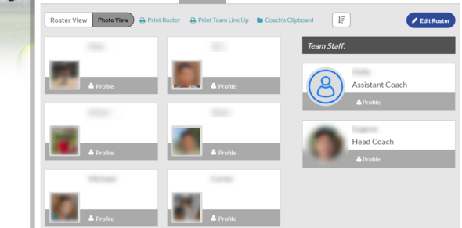](https://wiki.ayso.org/wiki/File:Roster.png)

Select Print Team Line Up

[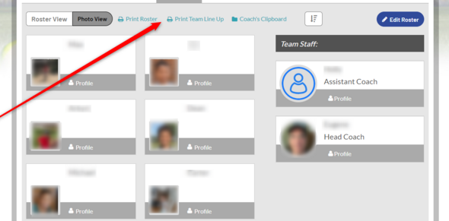](https://wiki.ayso.org/wiki/File:Line_up.png)

Export preference file:

[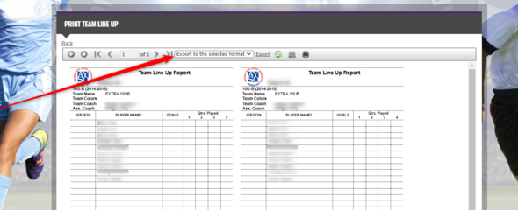](https://wiki.ayso.org/wiki/File:Print_line_up_2.png)

**Add Jersey Numbers to the Line Up Card**

* Team volunteer then goes to "Edit Roster" and enter the jersey number in "No." box and "Order" box.

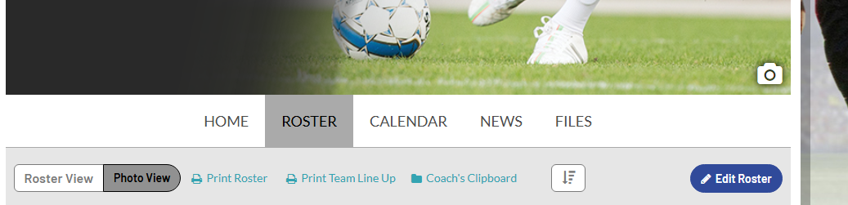

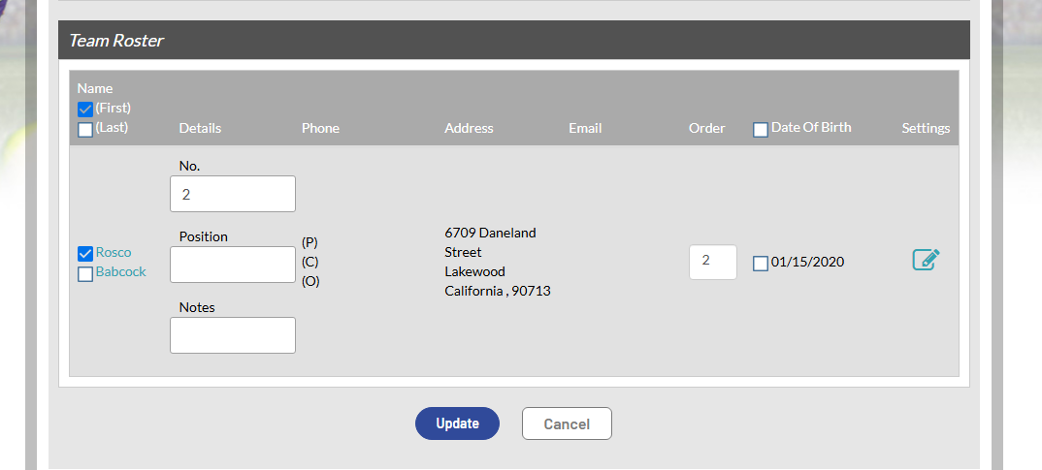

* Scroll down and click "Update". The lineup card can now be printed with jersey numbers.